**Unit test Cases on Spring-App**

**Command:**

mvn test

**Screenshots:**

Screenshot of 6 test cases run in TestExampleService

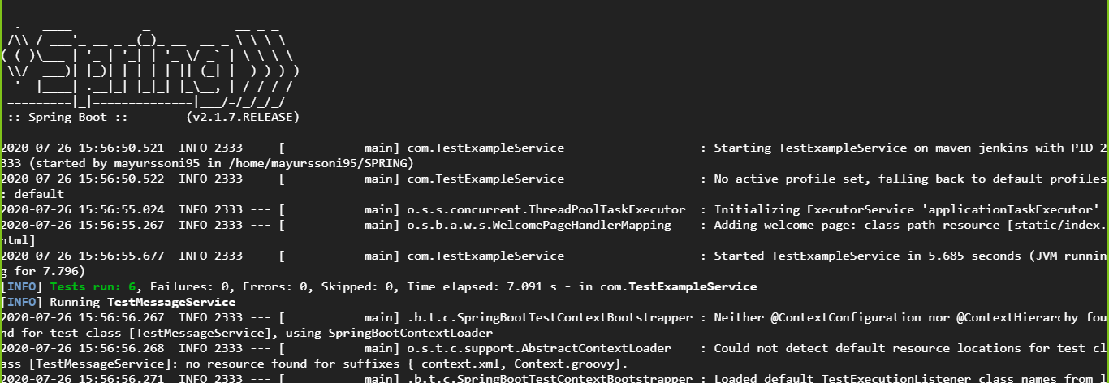

Screenshot of 5 test cases run in TestMessageService. Total test cases 11. 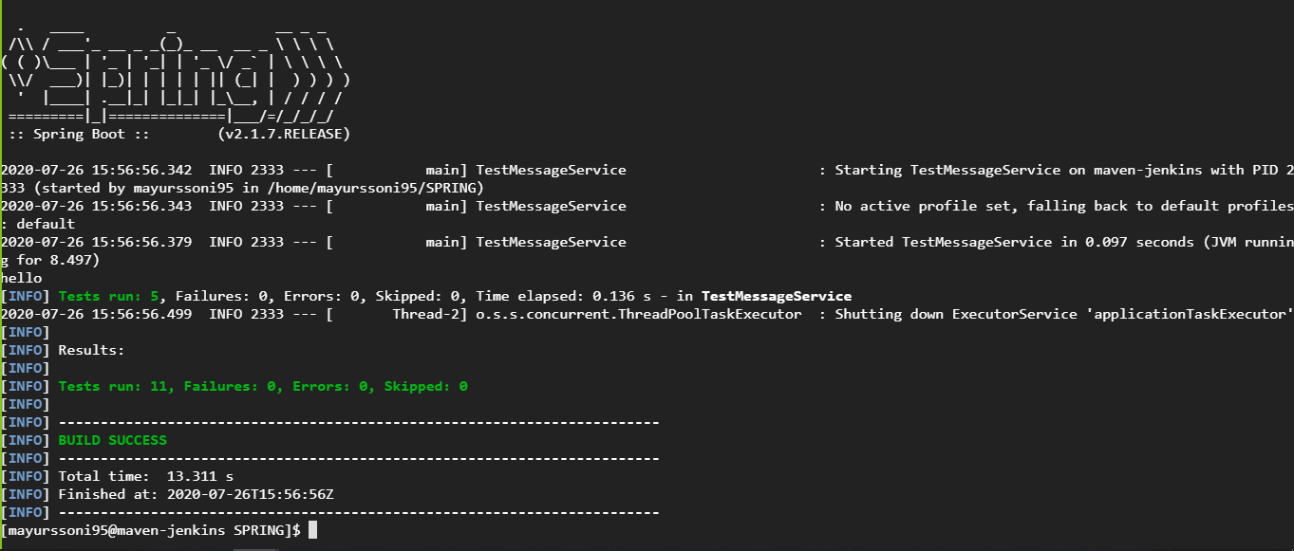

Test case failure if expected output not match.

